DO YOU SUFFER FROM CHRONIC DRY EYE?

**DRY EYE AFFECTS 30 MILLION PEOPLE**



We offer the latest technology to help in the treatment of dry eye. Treatment in the past has been limited to home therapy and medications. The MiBoThermoFlo is a cost effective therapeutic medical device that offers you relief from the suffering of dry eye.

How it Works!

The MiboThermoFlo supplies continuous controlled heat that is applied to the outer skin of the eye lids along with heat transfer gel for a gentle massage. The heat is absorbed deep into the tissue and breaks down the hardened oils in the Meibomian glands. With a specific prescribed therapy regimen, the ducts of the Meibomian glands will secrete thinner and clearer oils which will allow for a healthier tear film.

The MiboThermoFlo consist of 3 treatments performed typically 1 week apart. The out of pocket cost of $450 includes all 3 treatments. Subsequent follow-up treatments to maintain the best benefits are $25 per eye for each treatment.

**BENEFITS WITH TREATMENT** 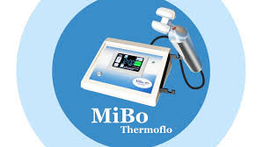

NO PAIN

NO DOWNTIME

NO SIDE EFFECTS

98% PATIENT SATISFACTION

MOST PATIENTS FEEL IMMEDIATE RELIEF

CALL 281-328-2020 TO SET UP YOUR APPOINTMENT TODAY