TREATMENT FOR MEIBOMIAN GLAND DYSFUNCTION OR EVAPORATIVE DRY EYE
- Mechanical Therapy
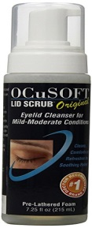
Eye lid scrub: Dispense one pump of Ocusoft Lid Scrub foam on to a wash cloth, cotton ball or sponge. Scrub the eyelid margins and eye lashes with the soap (as if you were attempting to remove make-up or matter from the eyelid) and then rinse with water.

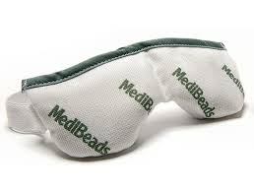
Warm Compresses: Apply heat to the eyelids in the form of a heating pad, a water bottle full of warm water, a boiled egg, or even a sock filled with rice that is warmed in the microwave. Maintain heat for about five (5) minutes.

Eye lid massage: Look away from the lid that you are treating (if you are working on upper eyelid, look down and look up for lower eyelid). Place the pad of your forefinger at the edge of the lid margin where the eyelashes meet the eyelid. Apply constant pressure so that the eyelid is pressed between the finger and the white of the eye. Hold the pressure for five (5) seconds and then move to the next section of the eyelid and press. You should be able to press in 4 – 5 places along either eyelid. Be careful not to roll the eyelid out or in or push upward on the eyelid as this will not produce the type of pressure necessary to clear the glands.

Perform these three tasks two times per day for a maximum benefit. If you are unable to perform all tasks, please do the eyelid massage-which is the most important step and can be done any time or place. Visit www.thefamilyvisioncenter.com/Resources/Instructions for instructional videos.

- Artificial Tears
Retaine: Preservative-Free ophthalmic emulsion that moisturizes, lubricates, and protects moderate to severe dry eyes. Unlike other lubricant eye drops that can evaporate quickly.

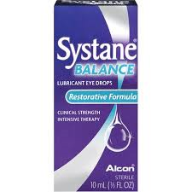
Systane Balance: Lubricant Eye Drops help support and restore your eyes' delicate lipid layer by replenishing essential moisture to your eyes. This clinical-strength intensive therapy provides lasting relief from moderate to severe symptoms of dry eye.

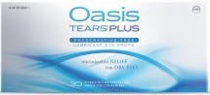
OASIS Tears PLUS: Lubricant Eye Drops coat, lubricate, and moisten delicate eye tissue. With each blink of your eye, a special substance in Oasis TEARS combines with the active ingredient, glycerin, to keep tears on the eye surface for a long time. This unique combination coats the recoats the surface of the eye for continued relief of dry, irritated eyes.

- Topical Prescription Therapy
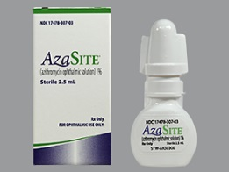
Azasite Therapy: By prescription only. Store dropper bottle with tip down or on its side. The solution is viscous and may take a long time to travel into the tip of the bottle, making it seem like the bottle is empty. Just before bedtime, squeeze one drop onto the tip of your finger and spread the medicine across the eyelid margin at the base of the eyelashes of both upper and lower lids. Do not wipe the medicine off the eyelids. Go to sleep and allow the medicine to
penetrate the lids overnight. This medicine may be used every day until the bottle is empty, if necessary, refills are permitted and use may be resumed as often as necessary whenever symptoms resurface.

  - Oral Prescription Therapy
Oral Doxycycline Therapy: One 100mg tablet to be taken by mouth once in the morning with food. The typical course lasts 20 days. Always take this medicine with food. (Swallow some food before the pill and some after the pill) and do not lie down for 10 minutes after swallowing the pill. Do not take with dairy products and do not spend extended periods of time out in the sun while taking this medicine. If using birth control pills, please note that the efficacy of birth control is significantly reduced by this medication and alternate means of contraception will be necessary for the duration of the menstrual cycle that is concurrent with this therapy.

  - Supplement Therapy
For additional benefit, you may choose to add vitamin supplements to your diet: 1000mg – 2000mg of flax seed oil and omega 3 fatty acids are helpful in combating this type of dry eye.

